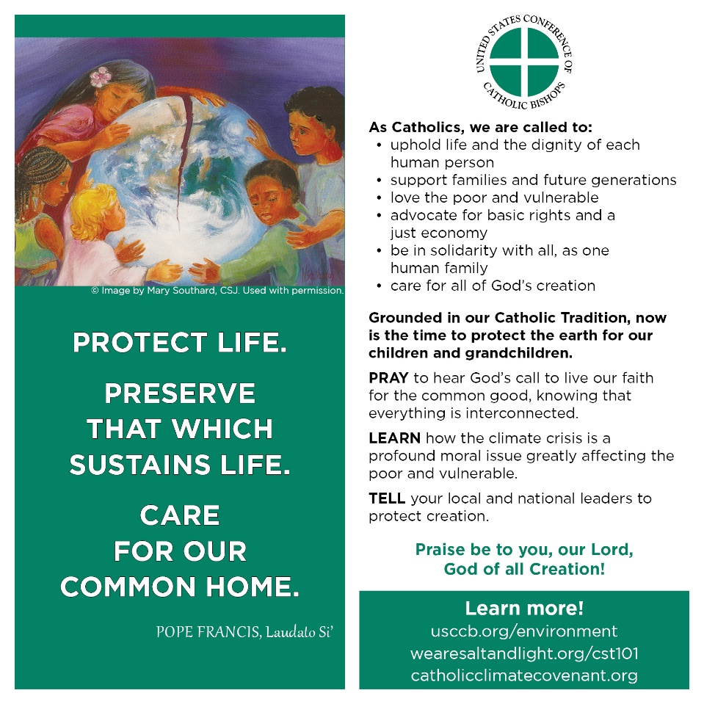
Commemorating the 5th anniversary of Laudato Si’ – on Care for Our Common Home

During the week of May 16 - May 24, the United States Conference of Catholic Bishops (USCCB) and its "Communities of Salt and Light" project, which focuses on the social teachings of the church, is joining with the Catholic Climate Covenant and Catholics worldwide to commemorate the 5th anniversary of Pope Francis' encyclical Laudato Si' - On Care for Our Common Home.

The USCCB has made some good resources available for committing ourselves ever more deeply to caring for God's creation, from prayer to education to action. Those resources can be found here: http://www.usccb.org/issues-and-action/human-life-and-dignity/environment/

Because the Covid-19 crisis confines us to meeting in the online world for our liturgies and for sharing our parish bulletin, the St Matthew Green Team encourages parishioners to take advantage of meeting this way by following this USCCB links herein.

One simple thing we all can do is to print out a copy of the "Protect Life" card that the USCCB approved for distribution to American Catholics (shown above). You can access that here:
http://www.usccb.org/issues-and-action/human-life-and-dignity/environment/upload/laudato-si-postcard-square.jpg If we were in church, we would be handing this out at Mass during the Laudato Si' anniversary week, but instead we are sharing it this way so that we can pass on to others.

With a critical election coming up this year, these cards are designed to transcend the impasse that has long existed in our Catholic Church over what "pro-life" and "respect for life" mean. These cards make room for considering that the protection of life also means caring for all God's creation and voting for leaders who will commit to doing so.

"Tell your local and national leaders to protect creation," the card reads. If you print out this card and put it on your refrigerator, or you share it over social media, you will be delivering an important message to those you love and those who love you that you think care for creation also means taking action on the climate crisis, which includes choosing leaders who recognize the problem and are offering plans to do something about it.

Here are the other resources mentioned on the card:
USCCB/Communities of Salt and Light
https://www.wearesaltandlight.org/catholic-social-teaching-101
Catholic Climate Covenant
https://catholicclimatecovenant.org/

