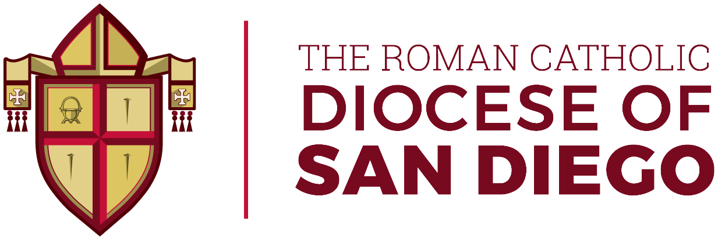

Sept. 12, 2021

Message from Bishop Robert W. McElroy, Diocese of San Diego:

I am speaking to you today to introduce you to an initiative that is taking place in every parish of our diocese over the coming weeks to renew our understanding of and love for the Eucharist. The Eucharist is the source and summit of the Christian life. In it we receive the Real Presence of the Lord Jesus Christ by whom we have been redeemed. Yet many
faith-filled Catholics have questions or misconceptions about the meaning of Eucharist for us and for our world.
For this reason, we will be presenting to you today and on the following two Sundays homilies preached by priests of our diocese on the most important realities of the gift of the Eucharist. This will be followed by three Sundays in which we will highlight and explain each section of the Mass as it is celebrated.
It is my deepest hope that these weeks will be for us all a time to grow in our love for and understanding of this most beautiful sacrament, and in doing so come closer to the God who has bestowed upon us every blessing we know in this world.
Thank you for your faith, and your love for the Church.

